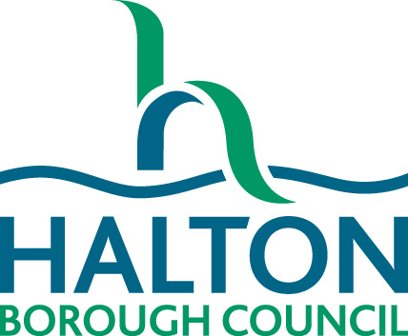

My Transition Plan

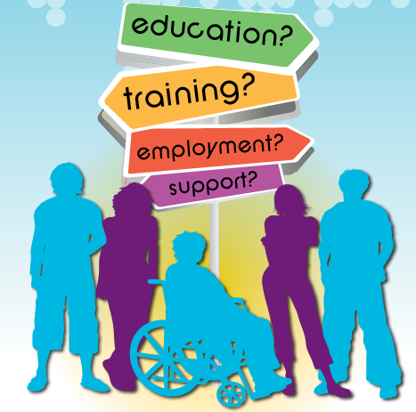

|  |  |
| --- | --- |
| Name of young person: |  |
| Date of completion: |  |

Personal information

|  |  |
| --- | --- |
| Name: |  |
| Date of Birth: |  |
| Address: |  |
| Telephone number: |  |
| School/college: |  |
| GP: |  |
| Next of kin: |  |

Reference information

|  |  |
| --- | --- |
| Parent/guardian details: |  |
| Lead professional: |  |
| Key education worker: |  |
| EHC Plan Co-ordinator/SEN PA: |  |
| Health professional: |  |
| Social Worker: |  |
| Advocate: |  |
| Personal Advisor: |  |
| Others: |  |
| Friends: |  |

All about me

Things I like…

|  |
| --- |
|  |

Things I don’t like…

|  |
| --- |
|  |

My aims, goals and ambitions for the future…

|  |
| --- |
|  |

Education / training

|  |
| --- |
| Your education so far.  Have you gained any qualifications, if so what are these? |
|  |
| Do you have an Education Health Care plan or Statement? Yes/No. |
|  |
| Action Plan.  What needs to happen to meet your short term goals?  What needs to happen to meet your long term goals? |
|  |

Support and Independent Living Skills

|  |
| --- |
| What independent living skills do you have?  Think about: self-care (getting washed, dressed, choosing your clothes), domestic chores, money management, travelling independently. |
|  |
| Does anything need to change to help you be more independent? |
|  |
| Do you have a Personal Budget?  If so, do you know how much your Personal Budget is? And how do you use it? |
|  |

Health

|  |  |
| --- | --- |
| GP: |  |
| Dentist: |  |
| Speech and Language Therapist: |  |
| Other health professional(s): |  |
| Your health needs: | |
| Physical health: | |
| Mental health: | |
| Does anybody help you to manage your health?  Do you need any more support to manage your health? | |
|  | |

Accommodation

|  |
| --- |
| Where do you live now? Who do you live with? |
|  |
| Where do you think you would like to live in the future?  Think about: Do you want to share a house? Where would you like to live? Will you need support from other people to live in your own house? |
|  |

Finance

|  |
| --- |
| Do you have your own bank account? Yes / No |
|  |
| Do you manage your own money? Yes / No |
| If no who helps you? |
| Do you know what your income is? |
|  |
| Do you need a referral to Welfare Rights to make sure you are getting right benefits? |
|  |

Employment / work-based experience

|  |
| --- |
| Are you currently working? If no, do you need help to find work? |
|  |
| What job do you think you would like to do in the future?  What are your ambitions? |
|  |

Leisure activities / hobbies

|  |
| --- |
| What do you really enjoy? |
|  |
| Are there any other activities you would like to do? |
|  |
| Do you need any support to find new hobbies or activities? |
|  |

Summary of transition plan

|  |  |  |  |  |
| --- | --- | --- | --- | --- |
| Summary of each area: | | | | Action required (with responsibility and timescale): |
| Education / training: | | | |  |
| Support and Independent living skills: | | | |  |
| Health: | | | |  |
| Accommodation: | | | |  |
| Equipment: | | | |  |
| Finance: | | | |  |
| Employment / work-based experience: | | | |  |
| Leisure activities / hobbies: | | | |  |
| Date: |  | Next review: |  | |

Agreement

|  |  |  |
| --- | --- | --- |
| Young person’s views: | | |
|  | | |
| Parent’s/Carer’s views: | | |
|  | | |
| All professionals involved in this Plan agree to undertake identified tasks, to achieve the best possible outcome. All participants of this Plan will maintain close contact to monitor progress. | | |
| Name: |  | |
| Name: |  | |
| Name: |  | |
| Name: |  | |
| Name: |  | |
| Review date: | |  |