Appendix F
Support plan template

From West Sussex EPS (2019).
Support Plan
Name: | Date:
At school these things can make me feel upset:
My key adult(s) in school is/are:
When I can speak to my key adult(s):

Where I can speak to my key adult(s):

Until __________ my return to school plan includes the following changes to my attendance:
(Identify any changes to days or time they come in)

Changes to my timetable include:
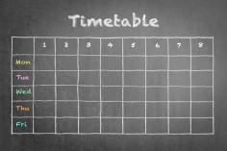
(Identify any changes needed and what should happen/ where they should go instead)

Any other changes include:
Identify any other changes to routines, (break, lunch times, changes between lessons etc.) classroom expectations (not expected to read aloud, work in pairs etc.) or homework.

When I start to get upset, I notice these things about myself:
When I start to get upset, others notice these things about me:
Things I can do to make myself feel better when I’m at school:
Things that other people (staff and friends) can do to help me feel better when I’m at school:

Things that my family can do to support me to attend school:
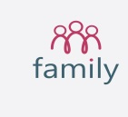

Places in the school I can go to where I feel safe and supported:
This plan will be reviewed regularly so that it remains helpful.

Review date:

My signature | Key adult’s signature | Parent signature
Other people who have access to the plan are:

