 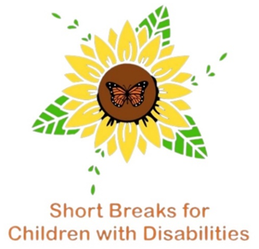 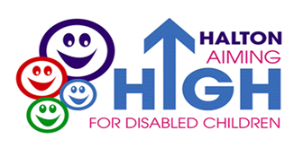



As a service for children and young people in Halton your parent/carer feedback is important to us. We would like to know your views on what has worked well, what we can improve on, what you like about the services we provide and what you think is missing in Halton.

Please return your completed form to: [AimingHigh.forDisabledChildren@halton.gov.uk](mailto:AimingHigh.forDisabledChildren@halton.gov.uk)

|  |
| --- |
| 1. Do you have a child with a disability or additional needs? If so what is their diagnosis, condition or type of need? |
| Give details below |

|  |
| --- |
| 1. How old is your child? |
| Give details below |

|  |  |  |  |
| --- | --- | --- | --- |
| 1. Where do you live? Please tick below | | | |
| Runcorn |  | Widnes |  |

|  |
| --- |
| 1. What School or Nursery does your child attend? |
| Give details below |

|  |  |  |  |
| --- | --- | --- | --- |
| 1. Is your child open to Halton’s Short Breaks Service for Children with Disabilities?   Please tick below | | | |
| Yes |  | No |  |
| Give details below | | | |

|  |
| --- |
| 1. Does your child receive a short break package of support from our service? |
| Give details below |

|  |  |  |  |
| --- | --- | --- | --- |
| 1. Has your child accessed any of our commissioned services? Please tick below | | | |
| Yes |  | No |  |

|  |  |  |  |  |  |
| --- | --- | --- | --- | --- | --- |
| If yes, please tick the services attended below. | | | | | |
| Vibe Monthly Outdoor Group |  | Everton in the Community |  | Halton Play Council |  |
| Vibe Friendship Group |  | Sportworks Water Confidence Play Sessions |  | CAFT Forest School |  |
| MakoCreate |  | Sportworks Swimming Lessons |  | Motiv8sports Art and Drama Classes |  |

|  |
| --- |
| 1. Have you and your child attended or due to attend any of our Family Events, accessed any other youth activities such as HAF, Uniform Service, Guides, Brownies etc.   For Example: Focus Gym, Fuzzy Edds, Day trip to CAFT, Warrington Sensory Centre, Norton Priory Story Walk, Forest School, Story Walk – Halton Haven? |
| Give details below |
| 1. If you accessed our commissioned service or Family Events over the Summer Holidays we would like to hear your views and experiences.   Is there anything that you really liked and would like to access again? Is there anything you didn’t like? If so why? |
| Give details below |

|  |
| --- |
| 1. Do you think there was a good variety of activities for children of all ages over the Summer Holidays? |
| Give details below |

|  |
| --- |
| 1. Are there any particular activities or services that you think are missing in Halton? |
| Give details below |

|  |
| --- |
| 1. Are you aware of Halton’s Local Offer? Have you accessed Halton’s Local Offer? Would you like further information about Halton’s Local Offer? What are your views about the Local Offer if you have accessed it already? |
| Give details below |

|  |
| --- |
| 1. Have you previously attended one of our Parent/Carers Catch-up Meetings or Consultation Events? Would you like to attend future Parent/Carers Catch-up Meetings and Consultation Events? If so what day, time and area is best for you? |
| Give details below |

|  |
| --- |
| 1. Any additional comments |
| Give details below |

**Thank you so very much for taking your time to complete our survey**

Please return your completed form to: [AimingHigh.forDisabledChildren@halton.gov.uk](mailto:AimingHigh.forDisabledChildren@halton.gov.uk)