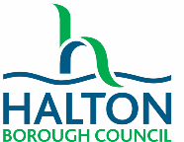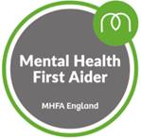**MHFA Youth Online**

|  |  |  |  |  |
| --- | --- | --- | --- | --- |
| Please select the course you would like to join | | | | |
| 7th Oct 2021, 14th Oct 2021, 21st Oct 2021 and 4th Nov 2021  All sessions run 2pm – 4.30pm | | | |  |
| 11th Jan 2022, 18th Jan 2022, 25th Jan 2022 and 1st Feb 2022  All sessions run 2pm – 4.30pm | | | |  |
| 22nd June 2022, 29th June 2022, 6th July 2022, 13th July 2022  All sessions run 2pm – 4.30pm | | | |  |
| **YOU HAVE TO PARTICIPATE IN ALL 4 SESSIONS IN ORDER TO PASS THE COURSE** | | | | |
| Please understand and agree to the following information:   * All places are offered on a first come, first served basis. * The course costs £40. This is paid as soon as materials are ordered as places cannot be cancelled once resources have been ordered. * Further information on the course can be found [here.](https://mhfaengland.org/individuals/youth/online-youth-mental-health-first-aid/) * Forms to be returned to [Vanessa.nice@halton.gov.uk](mailto:Vanessa.nice@halton.gov.uk) * You must have a laptop with a working microphone and webcam which is capable of running Microsoft Teams in order to take part. **This course does not run on handheld devices.** * You must be willing to fully participate in and engage with all 4 sessions with camera and microphone on (each session is approx. 2hrs long). * You agree to undertake the pre-session work before each session (about 1 hour per session). * You understand that you are required to complete an online evaluation in order to receive your certificate. | | | | |
| Name |  | School/Service |  | |
| Email address |  | Contact phone number |  | |
| Address for materials to be delivered to: | | | | |
| Signed |  | Date |  | |