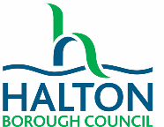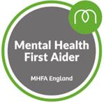**MHFA Adult In-person**

|  |  |  |  |  |
| --- | --- | --- | --- | --- |
| Please select the course you would like to join | | | | |
| 8th and 15th December 2021 9am – 4.30pm | | | |  |
| 2nd and 3rd March 2022 9am – 4.30pm | | | |  |
| **YOU HAVE TO ATTEND BOTH DAYS IN ORDER TO PASS THE COURSE** | | | | |
| Please understand and agree to the following information:   * All places are offered on a first come, first served basis. * All resources for this course are provided in a digital format and will be referred to during the course. You will need to bring your laptop. * If you’re joining this course from a school, the cost is £30 per person. This is paid as soon as materials are ordered as places cannot be cancelled once resources have been ordered. * No refreshments are offered on this course but time will be given for breaks and lunch * Further information on the course can be found [here.](https://mhfaengland.org/individuals/adult/2-day/) * Forms to be returned to [Vanessa.nice@halton.gov.uk](mailto:Vanessa.nice@halton.gov.uk) * This is a participatory course and you are asked to engage with activities (no role-play!) * You are required to complete an online evaluation in order to receive your certificate. | | | | |
| Name |  | Service/School |  | |
| Email address |  | Contact phone number |  | |
| Signed |  | Date |  | |