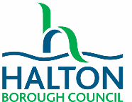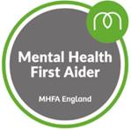**MHFA Adult Online**

|  |  |  |  |  |
| --- | --- | --- | --- | --- |
| Please select the course you would like to join | | | | |
| 25th Nov 2021, 2nd Dec 2021, 9th Dec 2021, 16th Dec 2021  All sessions run 10am – 12.30pm | | | |  |
| 3rd May 2022, 10th May, 2022, 17th May 2022, 24th May 2022  All sessions run 10am – 12.30pm | | | |  |
| **YOU HAVE TO PARTICIPATE IN ALL 4 SESSIONS IN ORDER TO PASS THE COURSE** | | | | |
| Please understand and agree to the following information:   * All places are offered on a first come, first served basis. * All resources for this course are provided in a digital format and will be referred to during the course. * If you’re joining this course from a school, the cost is £30 per person. This is paid as soon as materials are ordered as places cannot be cancelled once resources have been ordered. * Further information on the course can be found [here.](https://mhfaengland.org/individuals/adult/online-mental-health-first-aid/) * Forms to be returned to [Vanessa.nice@halton.gov.uk](mailto:Vanessa.nice@halton.gov.uk) * You must have a laptop with a working microphone and webcam which is capable of running Microsoft Teams in order to take part. **This course does not run on handheld devices.** * You must be willing to fully participate in and engage with all 4 sessions with camera and microphone on (each session is approx. 2hrs long). * You agree to undertake the pre-session work before each session (about 1 hour per session). * You understand that you are required to complete an online evaluation in order to receive your certificate. | | | | |
| Name |  | Service/School |  | |
| Email address |  | Contact phone number |  | |
| Signed |  | Date |  | |