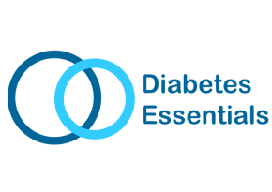
Type 2 Diabetes - Group Education/Information Sessions
Do you have a new diagnosis of type 2 diabetes?
Have you had diabetes for a while but need a diabetes update?
Would you like more information to support a family member with type 2 diabetes?

The Diabetes Essentials package provides a variety of half day, patient education sessions that provide encouragement, support and information to help manage your condition. You are very welcome to bring a family member or friend with you.

The session is delivered by the Countess of Chester NHS Foundation Trust in Partnership with Halton Clinical Commissioning Group.
Why should I attend this session?
- Do you need to learn more about diabetes?
- The session will give you the time to learn the essentials of diabetes management from a healthcare professional
- The information will be delivered in an easy to understand manner
- You will have the opportunity to have all your questions answered
- You will meet other people with the same condition and learn from their experiences
- You will find out about additional ongoing support in your local area.
What topics will be covered?
Diabetes Essentials aims to provide information on:
- What your diagnosis is
- How type 2 diabetes is monitored and managed
- Practical solutions to help manage your condition, including healthy lifestyle advice
When and where are the sessions held?
Sessions last approximately 2 ½ hours and are available across Runcorn and Widnes as follows:
- The Old Police Station, Mersey Road, Runcorn
- Castlefields Medical Centre, Runcorn
- Hough Green Medical Practice, Widnes
- Kingsway Learning Centre, Widnes
Sessions times vary depending upon location, however we have morning, afternoon and evening sessions available so you can choose the session to suit your schedule.
Is there a cost?
The session is a free NHS service. All venues have free parking available.
To book a session which is convenient to you please contact:
Therapy Services by telephone: 01244 365234 or email: Diabetes.Essentials@nhs.net

Check out our latest news on Facebook.com/DiabetesEssentialsRuncornandWidnes

