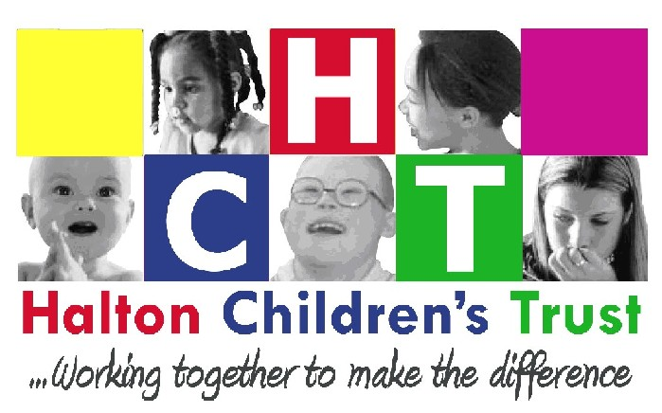

Halton Children’s Trust

Joint Commissioning Strategy

2018/2021

Version Number | Date | Author | Review Date
V2 | October 2017 | Clare Hunt | October 2018

Contents

1. Introduction 3
2. Background 4
3. National Guidance 4
4. The Commissioning Context 6
5. Halton’s approach to Commissioning 8
6. Commissioning Responsibilities 10
7. Priority areas for Joint Commissioning 14
8. Governance 19
9. Participation, engagement and consultation of all stakeholders 19
10. Conclusion 22

Appendix 1 Governance Structure 23

1. Introduction

“Halton’s ambition is to build stronger, safer communities which are able to support the development and learning of children and young people so they grow up feeling safe, secure, happy, healthy and ready to be Halton’s present and become Halton’s future.”

This framework is intended to provide support to those who work to improve services for children, young people, and their families in Halton. It is relevant to commissioners, providers, service users, and others who need to understand the commissioning process. It sets out the shared vision for Halton Children’s Trust so that common principles can be incorporated into the commissioning process and a common language is used to help all partners understand the commissioning process. It also defines what is meant by commissioning and sets out the ‘ground rules’ and steps required to decide how best to deploy resources.

The framework must be read alongside the Health and Wellbeing Strategy and Commissioning Plan, the NHS Halton Clinical Commissioning Group Two Year Planning Guidance and Operational Plan and the Children, Young People and Families Plan (CYPFP) which, following detailed consultation with children and young people, sets out the vision and priorities for joint working to improve outcomes for children and young people in Halton.

The framework sets out the context for the joint commissioning of children and young people’s services in Halton. For commissioning across children’s services we mean the approach that is used to agree local needs and to design and deliver services that will provide good outcomes for children and young people and meet the priorities set out in the CYPFP.

Halton defines commissioning as –
“the process for deciding how to use the total resources available in order to improve outcomes in the most efficient, effective, equitable and sustainable way.”

As well as responding to locally identified needs and priorities, commissioning in Halton is also largely shaped by national policy and guidance. Such guidance consistently identifies a number of key themes, which includes:

The objective of this framework is to make the best use of resources in the statutory, voluntary and private sectors to ensure the best outcomes for children, young people and their families in Halton. The framework takes an overarching view to adopting and embedding the process of commissioning within the context of Halton Children’s Trust whilst the detail for implementation will sit within the specific commissioning action plans which are developed.

2. Background

Halton is a largely urban area; its two biggest settlements are Widnes and Runcorn which face each other across the River Mersey, 10 miles upstream from Liverpool. The population of Halton has recently started to increase. This in part is due to a concerted effort to build new houses, as well as increased inward migration.

It has an increasing population current estimate of 126,903 (mid-2016 population estimate; June 2017, ONS). Breaking down Halton’s population by age shows that the borough has a higher proportion of children and young people aged 0-24 than commonly found across England and Wales.

The Borough is currently ranked as the 27th most deprived local authority in England and has a one of the highest proportions of children in poverty found in Cheshire and Merseyside. 25.9% of children in Halton live in poverty.

3. National Guidance

A range of new legislation has been introduced and it is clear that the Government expects the local authority role for children’s services to be primarily focused on vulnerable children, young people and their families, with an emphasis on early help.

A whole scale review into how local authorities and other agencies work together to safeguard children and young people was led by Professor Eileen Munro. This review of how well child protection services are working nationally highlighted the importance of the duty to co-operate by partners and working together to ensure sufficient provision of local early help services.

A Child Protection Inspection framework has been developed, based on the principles of Munro’s Review. This involves Ofsted inspectors talking directly to children and their families, shadowing social workers and observing multi-agency working. Ofsted will work with frontline social workers and managers to view case files and scrutinise the support provided for a child. A more all-encompassing focus also sees Inspectors evaluating Early Help systems and support for children, young people and families, before problems escalate, become critical and lead to more formal child protection processes.

Educational reforms have led to greater school autonomy, with the creation of Academy and Free Schools and a drive for a new qualification, the English Baccalaureate to define standards for young people. Working with schools, colleges and employers, local authorities are now responsible for promoting participation in education, employment or training for all 16 and 17 year olds.

Reforms to the system of support for children with special educational needs or disabilities (SEND) took place in March 2014, when the bill was approved and became the Children and Families Act 2014. From 2014 SEN Statements and separate learning difficulty assessments for older children have been replaced by a single birth to 25 assessment process and an education, health and care plan. Parents with such plans have the right to a personal budget for their child’s support. Councils and health services are required to jointly plan and commission the services that children, young people and families with SEN or disabilities need.

The Children and Families Act is a far reaching piece of child welfare legislation that will ensure:

The Act underpins wider reforms for adoption, looked after children, special educational needs and family justice. The main provisions within the act include:

- Adoption and Virtual School Head (VSH)
- Family Justice System
- Special Educational Needs (SEN)
- Childcare
- Office of the Children’s Commissioner (OCC)
- Shared Parental Leave and Flexible Working

The Government supports the need for agencies to work together to provide help efficiently and effectively but have removed the requirement for local authorities to set up a Children’s Trust Board. Many areas including Halton Borough Council have continued these boards to ensure partners commit to working together to jointly plan and commission services effectively. Guidance published by DCSF in April 2008 stated that:

“A Children’s Trust is, in part, a commissioning partnership, commissioning from self-determining providers. Joint planning and commissioning is a key means by which the Children’s Trust partners come together to make a reality of the duty to co-operate and drive cultural change. Commissioning is much more than contracting and procurement.”

Since such an approach was adopted by the Halton Children’s Trust, a number of pieces of legislation and guidance have been introduced which underpin and inform both this commissioning framework and the wider work of the Trust:

- The Apprenticeships, Skills, Children and Learning Act (2009)
- Children Act (2004)
- United Nations Convention on the Rights of the Child (UNCRC)
- Health and Social Care Act (2012)
- Education Act (2011)
- The Munro Review of Child Protection: A Final Report, A Child Centred System DFE (2011)
- Fair Society, Healthy Lives: The Marmot Review (2010)
- Early Intervention: The Next Steps :An Independent Report to Her Majesty’s Government Graham Allen MP HM Government (2011)
- Children and Families Act 2014
- Care Act 2014

4. The Commissioning Context

Halton’s Children, Young People and Families Plan 2018 -21 establishes our vision for children and young people in Halton to have the best possible start in life and to benefit from the opportunities that living in this borough provides. The Plan is informed by the Joint Strategic Needs Assessment (JSNA) and the Health and Wellbeing Strategy and helps us speak with one voice about the needs and aspirations of children and young people in Halton.
It is essential that Commissioners hear and respond to the voice of children, young people and their families, place their aspirations at the heart of everything they do and engage them in commissioning activity. We will know we have got this right when children, young people and their families agree that:
- Their voice has been heard
- Open and accessible consultation and robust research focuses on their needs
- They have opportunity to co-produce services
- Services effectively, efficiently, equitably and sustainably address their needs and aspirations.
- They have opportunity to safely raise concerns that are transparently addressed
- The environment is conducive to their being healthy, safe and achieving.
To ensure commissioning activity leads to fit for purpose services it needs to take place within the context of the whole system. We view this system as a complex array of interconnected parts affected by political, economic, social, technical, legal and environmental factors that collectively result in the environment that influences children, young people and families’ lives.

4.1 The Commissioning Cycle
The Trust recognises that commissioning takes place on a number of levels – strategic, operational and individual and on a borough wide, area and locality basis.

There are a number of different frameworks that try to capture the nature of commissioning. All tend to describe a cyclical process of activities reflecting four key stages:

- Analyse - population needs assessment and resource identification;
- Plan - aligning resources to meet needs; filling gaps between needs and services;
- Do - developing or purchasing services;
- Review - monitoring performance and evaluating outcomes.

The generic cycle of ‘analyse, plan, do, review,’ correlates with the processes of needs assessment and strategic planning, shaping and managing the market, and improving performance, monitoring and evaluating (with each stage informed by the previous one).

Key Activities Involved in Successful Commissioning
All activity will be focussed around eight distinct steps:
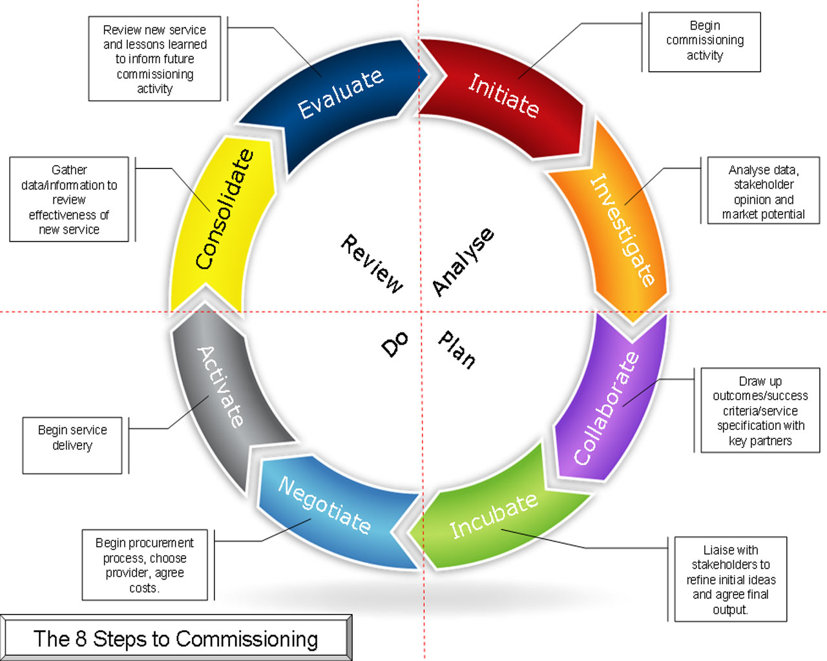

In order to be very clear from the outset the Trust has defined above what commissioning is, however it also needs to define the following components of the commissioning process in order to avoid confusion.
Commissioning Process Components

5. Halton’s approach to Commissioning

‘Commissioning is the process for deciding how to use the total resource available for children, young people, parents and carers in order to improve outcomes in the most efficient, effective, equitable and sustainable way.’ Achieving Better Outcomes: Commissioning in Children’s Services Commissioning Support Programme, 2009.

Commissioning in Halton is about assessing need, prioritising resources, reviewing and developing services to improve outcomes for Halton’s children and young people and their families.

With the establishment of NHS Halton CCG and the integration of the Public Health function into the local authority, Halton has had the opportunity to further develop its integrated commissioning arrangements across the borough.

Since 2014 through the Pan Cheshire Complex Needs Programme, Halton has been working in partnership our Cheshire partners and key partners within the borough to develop innovative and pioneering ways of working together to tackle the causes of crisis for children, families and adults. The programmes key priorities include the development of an integrated front door, locality case management, joint commissioning, workforce development and benefits realisation and performance management.

Reforms to the system of support for children with special educational needs and/or disabilities (SEND) requires partners to work more closely together to integrate the support on which children and families rely across education, health and social care. Services now work together to agree a straightforward, single plan that reflects the family’s ambition for their child from early years to adulthood.

Halton’s ambition is to build stronger, safer communities which are able to support the development and learning of children and young people so that they grow up feeling safe, secure, happy and healthy, and ready to be Halton’s present and Halton’s future.

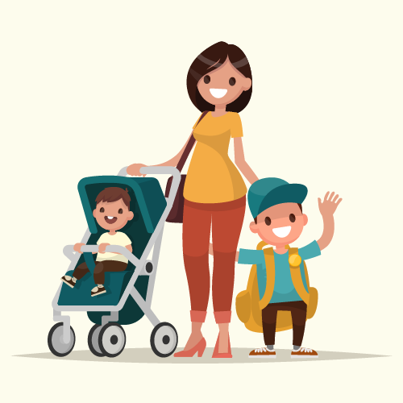
The Children Trust has identified its overarching priorities and each is an area where a strong partnership approach is needed to improve the outcomes for children and young people. These priorities are:
Young people want to feel healthy and safe at school, at home and in their community.

We want you to feel safe wherever you are and to understand how to look after your health.

If families don’t get support at the right time, problems become harder to sort out.

We want you and your family to get help when you need it.

Young people want to do as well in exams as they do in other parts of the country.

We want you to do well at school so that you can get the education, training or job that you want.

These strategic intentions are delivered through the Children and Families Commissioning Partnership which has agreed the following set of principles:

- We will take an outcome based approach to commissioning;
- We will understand the needs and priorities of our community, now and in the future and clearly specify our requirements;
- We will ensure that value for money and achieving sustainable efficiencies are the foundation of our commissioning solutions;
- We will ensure that children, young people, families and carers actively participate in our decisions about commissioning services at all stages of the commissioning cycle
- We will consult all relevant organisations, in advance of commissioning new services or undertaking de-commissioning/reshaping services
- We will support market developments to ensure there is a mixed economy of commissioned services enabling partners and individuals to deliver services where they can enhance outcomes and efficiency.
- We will build the capacity of our local third sector and small businesses to ensure they have equal opportunity to participate in commissioning;
- We will work jointly with other relevant local and regional commissioners to secure positive outcomes and value for money for the community
- We will ensure that tendering and procurement processes are transparent and fair
- We will promote sustainability with our providers to enable longer term planning
- We will use feedback from children, young people, families and partners to encourage innovation in the commissioning process and to achieve best practice
- We will monitor, evaluate and review our services rigorously and proportionately to ensure high quality outcomes and to reflect changes in demographic trends
- We will de-commission existing services where they do not deliver value for money or positive outcomes for children and young people and work together to avoid duplication
- We will keep informed about the changing national direction over time for all agencies within Children’s Trust and implement and this against local need.
- We will consider opportunities for sub-regional commissioning where appropriate, and look to bid for national funding individually and in conjunction with other local authorities.

5.1 Best value
Budgets are always finite and typically change year on year however as they usually come from the public purse we have a continuing duty to achieve best value. We therefore need to continue asking ourselves difficult questions about the impact and value of services. The answers from such service reviews provide us with opportunity to consider changes that need to take place. These changes may mean ceasing to provide particular activities, decommissioning, reshaping, integrating or growing successful services. When service reviews take place in an integrated manner there is opportunity for commissioners, providers and users of services to consider pooling resources.
Commissioning processes will take into account the strategic Return on Investment (ROI) that may be generated as a result of local activity. Local procurement processes will utilise concepts such as MEAT (the Most Economically Advantageous Tender) and the consideration of Social Value in order to ensure services represent the best possible value for money.
5.2 On-going organisational change
It is recognised that changes to statutory duties, governance structures, geographic boundary and budgets are accompanied by periods of transition for organisations. Each change is accompanied by a number of opportunities and challenges. During periods of change we need to clearly communicate changes with one another, collaboratively manage risks and continue providing high quality services.
5.3 Sustaining partnership ethos
We recognise that over a period of years we have continued to nurture and develop effective partnerships that are increasingly working in an integrated manner to create an environment conducive to improving the lives of children, young people and families.
5.4 Commissioning prioritises the improvement of outcomes
Our commissioning will focus on the improvement of outcomes rather than merely providing activities. When setting outcome targets for services we will take account of the relationship between the utilisation of inputs (costs, resources and time) to produce a set number of outputs (activities, users and units) to agreed standards (quality assurance) necessary to achieve the required outcomes.
We will ensure that outcomes are aligned to and contribute to the achievement of borough wide strategies. We will ensure services address an evidenced need. To do this we will continue to collect and analyse robust population and market data, such as that found in the JSNA, to arrive at a holistic understanding of our children and young people’s current and future levels of need and the market’s capacity to meet demands.

6. Commissioning Responsibilities
Each of the commissioning organisations within Halton has clear areas of responsibility which are described in the sections below. However, we believe that in most cases it takes more than one agency to provide the services needed by local communities and individuals.
We are committed to developing integrated commissioning arrangements that ensure all of the necessary agencies work closely together to complement and support integrated frontline delivery to meet the needs of local people.
6.1 Children and Young People’s Service’s
Where possible we jointly commission services with Halton CCG and/or Public Health. All the services commissioned are based on need which fulfil our commissioning priorities and contribute towards Halton Children’s Trust priorities in the CYPFP. We commission a range of services to support all children, young people and families in the borough and are responsible for:
Services and Support for Children and Young People

Services and Parents/Carers and Families

6.2 Public Health
Responsibility for Public Health transferred to local authorities from Primary Care Trusts in April 2013 giving local authorities the statutory duty to protect and promote the health of people in its area.

Local Councils have the commissioning responsibility for the following areas:

The Council commissions a wide range of services designed to contribute to the achievement of our priorities and improve population health. Service Providers include NHS Trusts who deliver services such as the 0-19 Healthy Child Programme (incorporating School Nursing, Health Visiting and Family Nurse Partnership) and the integrated Sexual Health service.

Services are also commissioned from voluntary organisations (e.g. Cancer support and Citizens Advice Bureau), General Practice (e.g. NHS Health Checks, Sexual Health services) and community Pharmacies (e.g. Emergency Hormonal Contraception, intermediate smoking cessation). Contracts take a variety of forms such as directly commissioned services, NHS block contracts, Service Level Agreements, collaborative investments, sub regional activity and through the use of a national non mandatory tariff for GUM services. The Public Health Team within the Council is supported by Public Health England, which is also responsible for commissioning national screening programmes and some elements of local provision.

Local Authorities are expected to set their health priorities based on their Health and Wellbeing Strategies, with a robust understanding of local needs set out with Joint Strategic Needs Assessment (JSNA) and take into account the indicators within the Public Health Outcomes Framework, NHS Outcomes Framework and the Adult Social Care Outcome Framework, as well as a whole range of national and local indicators relevant to assessing the health and wellbeing of the population that we serve.

6.3 NHS Halton Clinical Commissioning Group

NHS Halton Clinical Commissioning Group (CCG) is principally responsible for the planning and purchasing of health services for the people of Halton. The geographical area covered by NHS Halton CCG is coterminous with the local authority boundary.

NHS Halton CCG is a clinically led organisation formed from the 15 GP Practices in the Borough. It commissions services in partnership with Halton Borough Council and NHS England.

Its responsibilities include commissioning local services from both acute (hospital) and community providers and also local third sector organisations. The services are to support children and young people with physical health difficulties but also include emotional well-being and mental health problems as the commissioning of CAMHS services (targeted and specialist) falls within this remit.

In addition to CAMHS services a number of community services are commissioned in the community to support children and young people with SEN such as:

7. Priority areas for Joint Commissioning

Whilst the Trust commits and aspires to larger whole system approaches in the long term, this framework has identified a number of joint commissioning priorities.

These priority areas are:

7.1 0- 5 Development
Pregnancy, birth and the weeks and months beyond are a key time of change and development for parents, as well as for their baby. Each mother and father begins to learn about the new baby and gets to know his or her needs, as well as how to love and care for their child.

This is an extraordinary and life-defining time. It is also a demanding time, and while most parents do well, some may struggle to cope with the changes, to adjust to their new roles and to provide their child with the care he or she needs. Halton is working to improve maternal health services, enhance breastfeeding rates and ensure that perinatal mental health is a focus of activity.

We are also working hard to improved levels of early child development and this is one of the key priorities in the One Halton Health and Wellbeing Strategy 2017-2022.

What we do know is:
- By 3 years of age children in families living below the poverty line are 8 months behind in language and 9 months behind in school readiness compared to those with incomes above the poverty line.
- Activities such as daily reading, regular bedtimes and library visits can improve cognitive development
- Although in recent years there have been improvements in the percentage of children achieving a good level of development at age 5, Halton’s performance is poor when compared to others nationally – 2013 Halton 37% 2017 Halton 61% - gap 10% (national 71%)
- Hospital admissions due to injuries are higher than nationally at 144 per 10,000 in Halton children aged 0-4 years of age compared 129.6 per 10,000 in England (2016).

Enhancing school readiness, preventing accidents and increasing support to parents is vital. Following an independent review of Early Years a One Halton Child Development Group was established. This group developed a new Early Years Strategy and detailed Action Plan and produce a guide to parents on school readiness. We are committed to working together to deliver our vision “for every child to be given the best start in life so that they are happy, healthy and ready for learning”. We want all our children to be healthy, ambitious, learners thriving on nurture.

.

7.2 Early Intervention
Early Intervention means better outcomes for children and families. Effective Early Intervention will resolve problems before they become overwhelming and require high cost, reactive services.
Our vision is underpinned by a number of early intervention principles;
- Working together as a strong partnership to deliver an effective local offer of support
- Identifying the children, young people and families who need extra help and support at the earliest opportunity.
- Commitment to a ‘Think Family’ approach to the assessment of needs which will have a positive impact upon all individuals within the whole family.
- Listening to children, young people and families, and ensuring that the voice of children, young people and families is evident throughout our involvement.
- Delivering a whole-family approach, ensuring that we use interventions and approaches that we know make a difference and achieve good outcomes. Make every contact count – through effective assessment processes and by empowering professional’s to address recognised need of children, young people and their families at the first opportunity.
- Share information – in a timely way, avoiding the need for continuous or repetitive assessment and ‘starting again’, understanding the whole family’s needs, regardless of which individual service or setting they come to.
- Continuously improve – learning as we go along by monitoring, reviewing and evaluating the way that we work, gaining a better understanding of what helps families most, eliminating wasteful systems and bureaucracy and focusing our resources on making a positive difference.
We will deliver on our ambition through a revitalised and remodelled offer of Early Intervention. There will be a programme of change to develop more co-ordinated, cost-effective, timely and tailored support for children, young people and families. This will ensure a more joined up and evidence based approach to early intervention which should reduce demand for specialist and acute services, resulting in improved outcomes and life chances for families through their needs being met earlier and reduced costs across the whole system.

The Troubled Families programme has been expanded until 2020. The Focus is to develop new ways of working with families, which focus on lasting change, recognising that these approaches are likely to incur extra costs but that they will result in a shift in the way we work with these families in the future – reducing costs and improving outcomes.

The second phase is looking that in addition to the problems targeted in the current programme, the expanded programme will also focus on families who are:
- affected by domestic violence
- with vulnerable children, and
- with a range of mental and physical health problems,
- high risk of worklessness; and
- involved in crime from generation to generation

The introduction and implementation of the Early Help model will enable partners to have a clear structure on the process and journey for families. It would also be easier to highlight where partners resources would fit within the delivery model i.e. health visitors, education welfare, family support workers, police etc. It is the structures within the Early Help model that will truly be able to evidence the wider impact for our most vulnerable families.

The development of Early Help model is a phased approach of which the first phase has been completed in 2017 in the development of an enhanced, integrated multi- agency contact and referral team, iCART, resulting in one front door for children and families services no matter what the level of need. The second phase will be to re-establish two Early Help multi-agency teams one in Widnes and one in Runcorn these will deliver an effective local offer of support as well as being the gateway to more intensive interventions. A key focus will be problem solving to unlock issues and prevent needs from escalating.

There will be a focus on early help for 0-19 years with a focus on a more proactive, robust offer of universal plus services to 0 – 3 year olds through children’s centres and the healthy child programme, with a particular focus on early language, communication and attachment. Halton schools and nurseries have committed to the National Nurturing Schools programme and the establishment of Nurture Groups, to enhance teaching and learning and promote healthy outcomes for children and young people by focusing on their emotional needs and development as well as academic learning. The development of Nurture Groups will offer intensive support for children and young people experiencing more entrenched difficulties in the school environment.

The approach of this commissioning priority is to make clear links across all areas of work within the Local Authority and the CCG, particularly regarding gaps in provision and duplication of services.

7.3 Risk Taking Behaviour

Halton is working to increase young people’s awareness of the issues surrounding risky behaviours and to ensure that they know where to receive help, advice and support, thereby aiming to reduce the teenage conception rate and the number of young people frequently using illicit drugs, alcohol or volatile substances. Evidence shows that high quality relationships, sex education and drug and alcohol advise along with providing welcoming health services (in the right place, open at the right time) and friendly non-judgmental staff, help young people to reduce risk taking behaviour. However key to success is translating the evidence into a whole system approach, making teenage pregnancy and drug and alcohol misuse everybody’s business.

Halton’s Safeguarding Children Board worked in partnership across Cheshire to address and improve the way we are tackling the areas of child sexual exploitation and missing children. Halton has joint protocols and priorities to identify and manage risk and to ensure a consistent approach. Across the four Cheshire Local Authorities there is a joint collaboration around a commissioned service for CSE and Missing.

7.4 Emotional Health and Mental Wellbeing

The purpose of the commissioning priority is to jointly review the current children and young people’s emotional health and well-being provision across the borough to improve access and outcomes for vulnerable children and young people.
The 2015 Department of Education and NHS England report Future in Mind emphasised the need to improve the following:

• Promoting resilience, prevention and early intervention
• Improving access to effective support – a system without tiers
• Care for the most vulnerable
• Accountability and transparency
• Developing the workforce

The Children’s Trust recognises the importance of emotional and mental health and wellbeing and is working with the elected members to ensure improvements are achieved. We are all working hard to ensure children and young people’s goals and ambitions can be achieved. We want them to grow up to be confident and resilient so they can develop and fulfil these goals and make a contribution to society.

The Trust will make sure parents and carers get the help they need to support children and young people through childhood and into adult life. We are supporting GPs, midwives, health visitors, teachers and other people who work in schools and the community, to understand emotional and mental health in children and young people, and know what to do and where to go if they are worried about them.

7.5 Special Educational Needs (SEN) High Needs

The Children & Families Act, 2014 sets out wide-ranging changes to improve outcomes for children and young people who have been identified as having a Special Educational Need. ‘Education, Health and Care Plans’ were introduced from 1 September, 2014, replacing Statements of Special Educational Need. A Plan now integrates support for children, young people and their families across education, health and social care. Services are now encouraged to work more effectively, together with children, young people and families, to agree a straightforward, single plan that reflects aspirations and develops alongside the young person on their pathway into adulthood. Plans can be reviewed regularly to reflect changing needs will be clear about who is responsible for provision and have a specific focus around achievement of outcomes.

The commissioning team will work on local and a regional basis with CCG colleagues and other local authorities, providing this meets identified local needs, to implement and sustain clear routes to the provider markets for a variety of services including Short Breaks for Disabled Young People as well as support packages

The commissioning team will work closely with colleagues from the CCG and the SEN department to ensure that assessments, contracts and the quality assurance of providers are developed jointly to ensure the best outcomes are achieved with value for money being attained.

7.6 Children in Care (Looked After Children - LAC)

It is widely recognised that looked after children have the poorest outcomes and are one of the most vulnerable cohorts within society today. Children who have been placed in care are at much higher risk of developing emotional and mental health problems than the average. The outcomes for children in care on a range of indicators are poor. The numbers of children in care represent a small proportion of the children in families with suboptimal care. Children in care are also widely recognised to have poorer educational outcomes and other health problems.
This priority will assist in informing future commissioning priorities as well as looking to confirm co-ordination between services. The priority will offer oversight into potential collaborative commissioning approaches involving other neighbouring local authorities or by regional and sub-regional commissioning processes covering placements including Residential, Fostering and Leaving Care.

8. Governance

Whilst Children’s Trusts are no longer a statutory obligation, local commitment from all stakeholders has ensured the continued existence and operation of a local strategic partnership to oversee and direct an integrated way of working to improve the outcomes of children, young people and their families.

“A strong integrated governing body is the cornerstone of a Children’s Trust. It should include representatives of all key partners at senior level, determined to drive whole-system change through clear leadership and effective action, and have appropriate arrangements in place to ensure the voices of children, young people, parents and frontline workers are heard”

Children’s Trust: Statutory guidance on inter-agency cooperation to improve well-being of children, young people and their families 2008.

The Children, Young People and Families Plan (CYPFP) is informed by the Children’s Joint Strategic Needs Assessment (JSNA). The CYPFP will be used to advise all commissioning strategies and activities and ensure outcomes sought are based on a clear understanding of local need. The Children’s Trust Board has the responsibility for developing and agreeing the CYPFP, the Board is responsible for setting the strategic vision and direction whilst ensuring the commissioning cycle is followed through. The Children’s Trust provides a strategic framework within which partners may agree to commission services together with integrated, shared, pooled or aligned resources. The Trust governance structure can be seen in Appendix 1.

9. Participation, engagement and consultation of all stakeholders

“Children, young people and families working collaboratively with professionals, will mean policies, services and provision will be more relevant, more effective and more sustainable”. Lansdown, G (2011) Global: A Framework for Monitoring and Evaluating Children’s Participation. A preparatory draft for piloting by Save the Children, together with UNICEF, Plan and World Vision.

Actively involving children and young people in service design, delivery and review is at the heart of this commissioning framework. Those children and young people who use services, and the families and carers that support them are best placed to provide informed opinion about how well services are performing, how effective they are and how they could be improved to better meet local need and changing landscape.

Involvement and participation is an embedded process between children, young people and decision makers; who consistently work together to improve services and provision. It is about a culture of respect, involvement; and change, where everyone’s views are important.

Every child and young person is a member of society. Organisations provide services for people living in that community or society so it’s important that they are involved in the provision of services. Parents, carers and families also play a vital part in the development and delivery of services. This will ensure that a service is developed reflecting local needs and hopes and supports families to access the service.

In Halton we will seek to work around the lives of children, young people and their families, whatever their background, circumstances and abilities. Halton Children’s Trust recognises that all children, young people, parents and carers are experts in their own lives, and have a good contribution to make.

Through the Children, Young People and Families Plan, the Trust and all partners are able to provide clear leadership to focus all local activity. The Participation Strategy sits under the Children and Young, People and Families Plan and informs and reviews participation practices.

The Trust wants to foster active participation by as many people and agencies as possible and ensure that all commissioning activity can seek to find ways to make itself more accountable to communities through events, panels, area forums and open and transparent decision making processes. We achieve this through active engagement and giving children and young persons’ views and perspectives weight in decision making.

Steps that define our approach to participation and engagement:
Customer focus: Services and processes have to be designed around the needs of the people who actually use them. At the same time people need to have an appropriate role in specifying the services that are delivered.

Participation & engagement: Partners will create specific and purposeful opportunities for people to give their views on what is needed and how it should be delivered. Partners will be supported to achieve a high standard of participation by INVOLVE group, who will act as a critical friend to the Trust on the participation of stakeholders in decision-making processes. Representatives on the group include young people, CCG, Halton Borough Council commissioning, service providers, Halton Family Voice and public stakeholders. We will work together towards an embedded culture of participation where people are actively involved in decision-making, service specification and design and every stage of the process.

Communication: Letting people know what is happening, how they can get involved and encouraging dialogue between partners and local communities is vital. Various media and methods will be used in appropriate and sensitive ways to build and maintain the communication effort.

Community empowerment is about members of a community feeling able to achieve their own goals, with some measure of control over the processes and strategies to attain these. It is a process whereby communities are encouraged to become increasingly self-reliant in improving their neighbourhoods and livelihoods. It is a cyclical, participatory process where local people co-operate in formal or informal groups to share their knowledge and experiences and to achieve common objectives. It is a process rather than a blueprint, and one that underpins this commissioning framework. The importance of children and family voice has been recognised by the Trust and the capturing, recording and responding to local need will be a central element of all commissioned activity through the regular collection of feedback and case studies.

Co-production: Means professionals and the community sharing power to plan, design and deliver support together. It's about recognising that everyone has an important contribution to make to improve quality of life for people and communities. For commissioning this means equally involving people who use services, carers, families and communities throughout the commissioning cycle. Here, people will help to:
- Explain about local needs, aspirations and assets.
- Make important decisions about what things are needed to make sure people have better lives and how to make these things happen.
- Decide which providers are chosen to provide services and supports.
- Check and feedback about how well providers are doing and how they could do better.
As commissioners we need to use co-production principles to use the depth of knowledge and experience to enable transformational change. A co-production approach increases the scope for people to influence and shape the support they receive as individuals and as a community, ensuring strong working relationships.

10. Conclusion

Halton is committed to developing its commissioning function to ensure it can continue to meet the needs of local people.

Overall identified priorities are those which are agreed by partners as being the ones needed to improve outcomes for children and young people. They are informed by the views of children, young people and their families.

The initial focus of this Strategy is to ensure that commissioning is coherent and effective and can deliver cost effective services that promote good outcomes for children, young people and their families. There is a joint commitment to the principles and ways of working outlined in this Strategy, with constant review and improvement at the heart of all local activity, so that we can meet Halton’s ambition to build stronger, safer communities which are able to support the development and learning of children and young people so they grow up feeling safe, secure happy and healthy, and ready to be Halton’s present and Halton’s future

APPENDIX 1

GOVERNANCE STRUCTURE
Halton Children’s Trust Board

SEND Strategic Group

Health and Wellbeing Board

Local Children’s Safeguarding Board

Halton Youth Cabinet

Children in Care Council

SEND Review

Preparing for Adulthood Strategic Group

EHC Plans Audit Group

Commissioning Partnership

SEND
Commissioning Partnership Board

Halton ImPart & Halton Family Voice

INVOLVE Group

