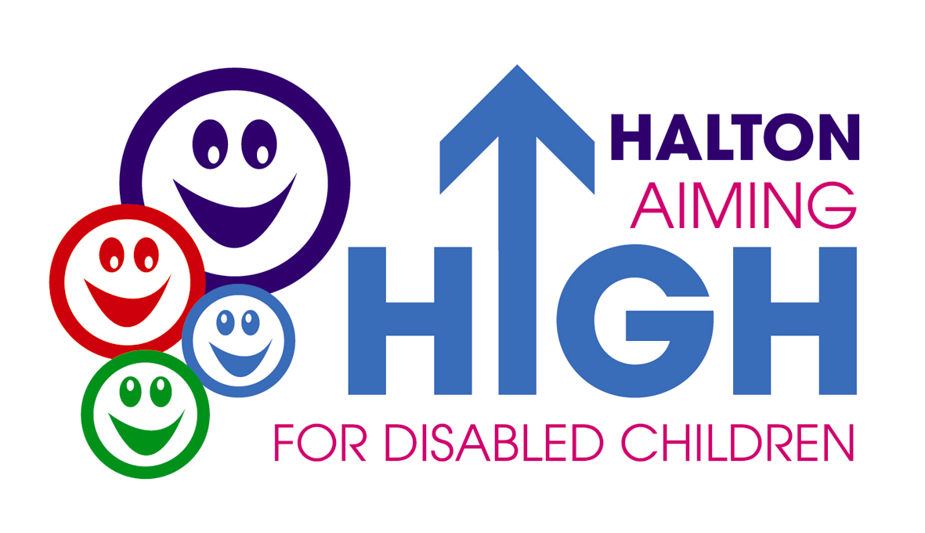

Short Breaks Review Document

My Short Breaks Review will be held 6 or 12 months after my Plan is agreed. I will tell you what I enjoy about my Short Break and anything that I don’t like.

My Parents/Carer and the people who help me will also say what is working well, or not so well for me, during my Short Break. We can agree if anything needs to change and what support I will need in future so that I can have fun and my Parents/Carer can enjoy their break. This will be written up in my new Short Breaks Plan.

My Short Breaks Profile will be updated after my Review and shared with the people who provide my Short Breaks service.

Reviewing My Short Breaks Plan

My Name is:……………………………………................

My D.O.B is:…………………………………………………

Date my Plan was reviewed:………………...……….…

Who has helped me to review my Plan?

Name | Title

What I do and Where I Go Now?

Here is a list of the places I go to, the activities I do and who helps me to do them.

Time of week | What I do?
After School
At the

Weekends
In School Holidays

What I enjoyed most and why?

Things I found difficult and why

How have the activities made life better for me?

How have the activities made life better for my family?

Changes that need to be made to my Profile

