Supporting D/deaf children, young people and their families to:

IMPROVE DEAF AWARENESS and COMMUNICATION through home based, fun sessions tailored to your Child’s needs

Our aims are to:
IMPROVE DEAF CHILDREN & YOUNG PEOPLE’S .....
- SELF CONFIDENCE
- INDEPENDENCE
- INCLUSION IN COMMUNITY ACTIVITIES

Clear and Confident Communication is the goal

A referral form can be found on the reverse of this leaflet. Simply post to:
Pam Craige
I’m Hear! Project Coordinator
Deafness Support Network
144 London Road
Northwich
Cheshire
CW9 5HH
Or faxed to:
Or
To discuss a referral or complete an electronic referral, please contact:
Pam Craige
Project Coordinator on 0808 208 2440 (voice)
Textphone: 01606 350823
Email pcraige@dsnonline.co.uk
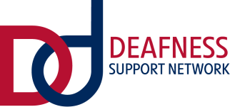
DID YOU KNOW?

Provides free communication support sessions and advice for families of children aged
0 – 18 years with any type of deafness through our new...

I’m Hear! Project
Cheshire East
Cheshire West & Chester
Halton
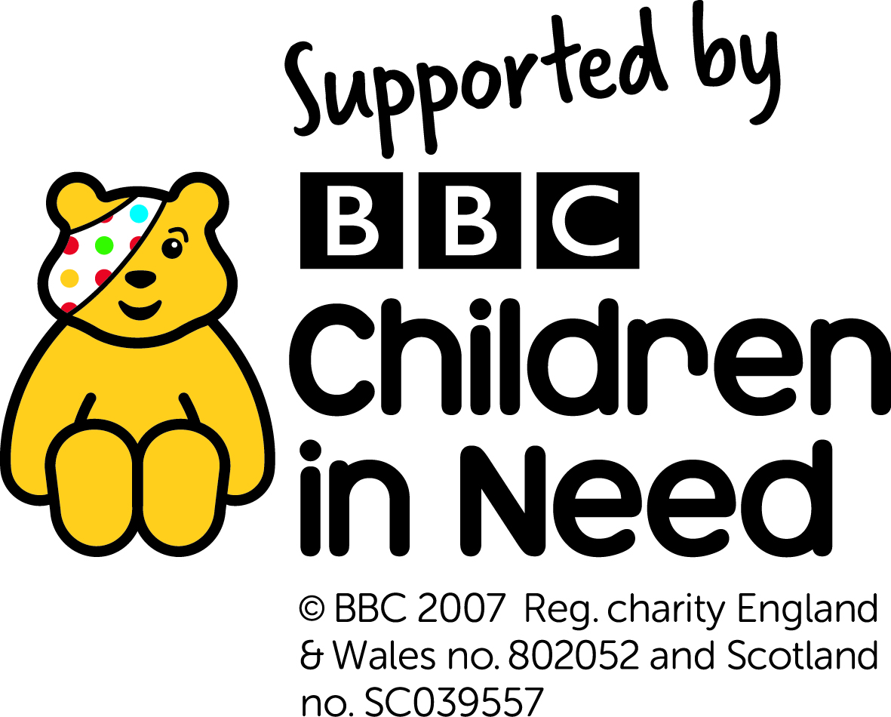
Warrington
Wirral

